**Shell Scripting**

To list all the Shells present in the OS:

**Cat /etc/Shells**

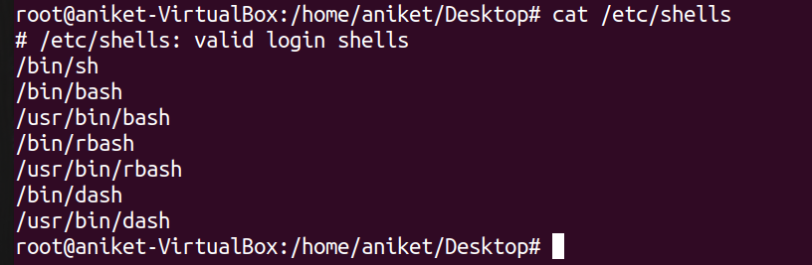

**Which bash**

To know the location of the bash



**touch shell1.sh**

To create zero byte file.

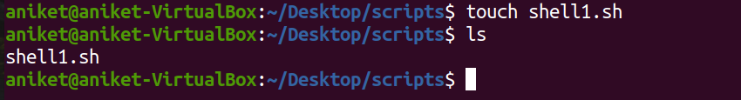

Write the Shell Script by using VI editor:

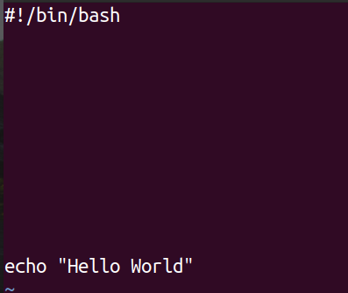

To executes the shell file, use:

**./shell1.sh**

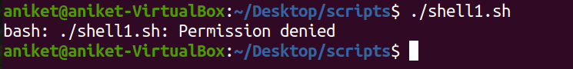

Here we don’t have permission to execute the shell file. Hence, to change the permission we have to use the **chmod** command.

To change the permission of the file.

**chmod +x shell1.sh**

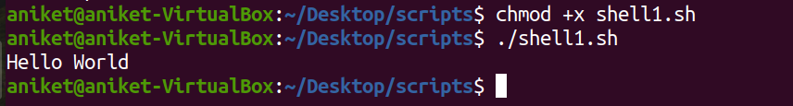

**Declare an Array in Bash:**

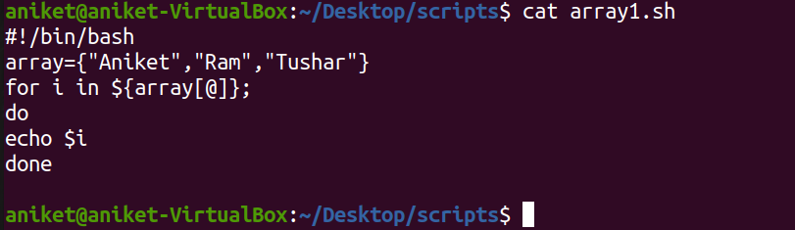

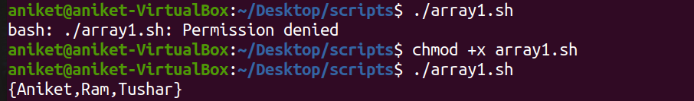

**Traversing through the array using Array Indices:**

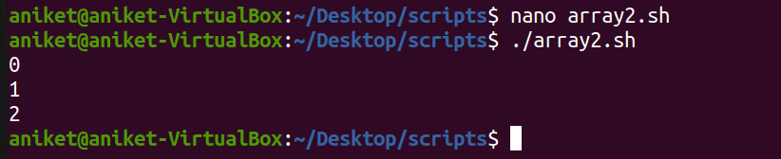

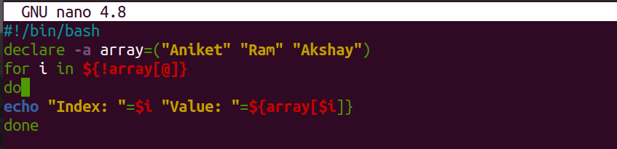

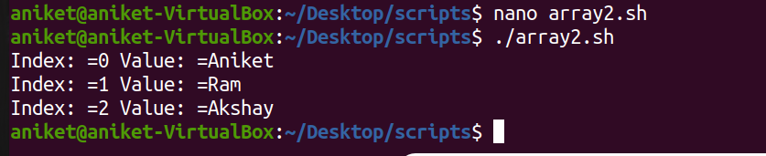

**Traversing by using counter-indexing:**

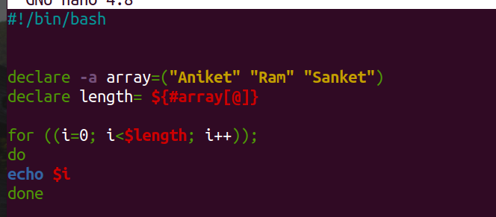

**Read User Input:**

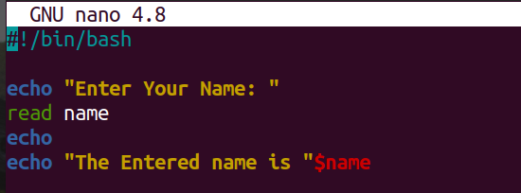

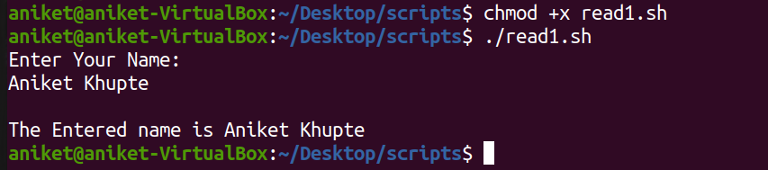

To list